**FPT Aptech**

2021

**T2103E**

Lecturer: Mr. Quang Nguyen Van

Students: Nguyễn Trần Quý, Lê Khả Đức Anh, Lê Hữu Hiệp,

Tống Minh Đức

Lecturer: Mr. Quang Nguyen Van

**Cosy Airconditioners eProject Report**

Table of Contents

***1.*** ***Acknowledgements*** 2

***2.*** ***eProject Synopsis*** 2

***3.*** ***eProject Analysis and Design*** 2

a. Homepage 3

b. Product Pages 5

c. Support Pages 9

d. Showroom page 13

e. Contact Us Page 14

f. About Us Page 15

g. Checkout Page 17

h. News & Experiments 18

***4.*** ***Site’s map*** 19

***5.*** ***User’s Guide*** 20

a. Register and login 20

b. Website Link 22

***6.*** ***Developer’s Guide*** 28

a. Download source code 28

b. Maintain HTML code 28

c. Maintain responsive 30

d. Maintain javascript 31

e. Extension 32

f. Browser support 32

1. Acknowledgements

Firstly, the success and final outcome of this project required a lot of guidance and assistance from many people and we are extremely privileged to have got this all along the completion of our project. All that we have done is only due to such supervision and council which mainly come from our lecturer Mr. Quang Nguyen Van whom we owe our deep gratitude to.

We feel thankful and fortunate to get constant encouragement, support and guidance from our family and friends that help us through this hard time of COVID epidemic.

Finally, we heartily give a thanks to our University - FE FAI HN for helping and providing us with learning opportunities despite the difficulties of the pandemic.

1. eProject Synopsis

In recent days, the pandemic has had a great impact on human daily lives. The quarantine and distance orders have had affecting people essential needs. Therefore, meeting the need to buy necessary items to get through this scorching hot summer, we came up with the idea of CozyAir.

Our goal is to make an e-commerce site that sells air conditioners so that we can meet the spike in demand for home air conditioner installation due to Work From Home following government directives.

Our website will be built with html, css and javascript and can be compatible with many devices from smartphones to computers.

1. eProject Analysis and Design

After discussion, we agreed that our website would include following main sections:

* 1. Homepage
* The navigation bar navigates to the sections located at the top of the web page.
* Our slogan.
* Banner image slider at the top of the page.
* New Products: Introduce new products.
* Limited Offers section: Introducing products that are on sale
* Section News: The relevant information
* Partner section: Company partners
* Testimonial section: Customer reviews
* Part Promise: Promise about service quality
* Footer section: Cozyair basics and QuickLink navigation to jump to subpages.
* Movetotop button: Return to the top of the web page.
* Quickchat button: Call for quick support.
* Search button: Search products by product name.
* Account button: Login / account registration form.

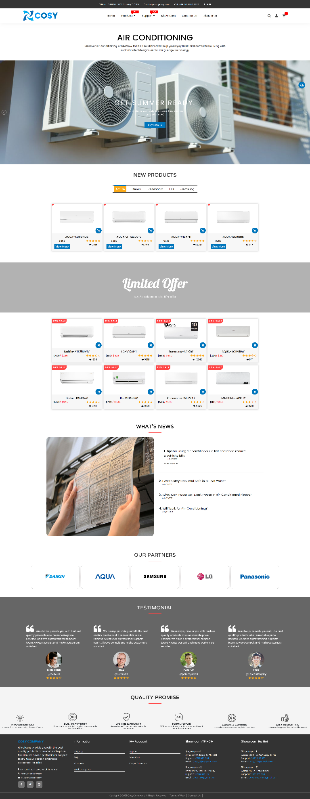

* 1. Product Pages

Products entry is divided into 3 sections:

* All products page
* Product by brand page(5 pages):

+ Aqua

+ Daikin

+ LG

+ Panasonic

+ Samsung

All product pages and product by brand consist of:

* Main content: A list of products.

In each product: Item-Code, Price, Add to Cart button, Find retailer button, Product’s rating, Link to product’s detail page, Product filter:

* + - Detail product: A detail information of product: Price, Name, Description, Select Quantity, Shipping information, Image List, Review, Additional Information, Checkout button, Customer reviews, Related Products.
    - Product filter: Name filter, price filter, Newness filter.
* Left filter: Filter according to Price, Brand, Performance.

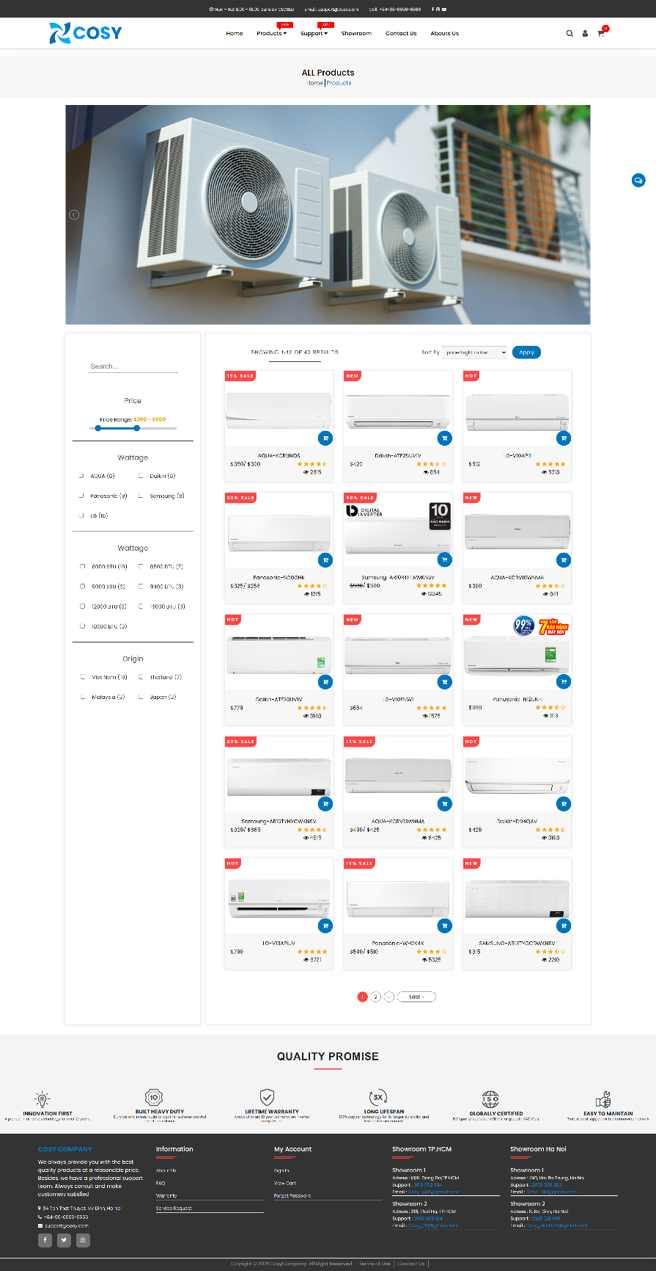

* Individual Page:
  + Overview: Product features
  + Images
  + Price
  + Specifications
  + User guide
  + Related Products
  + Customer Reviews
  + Compare to other product

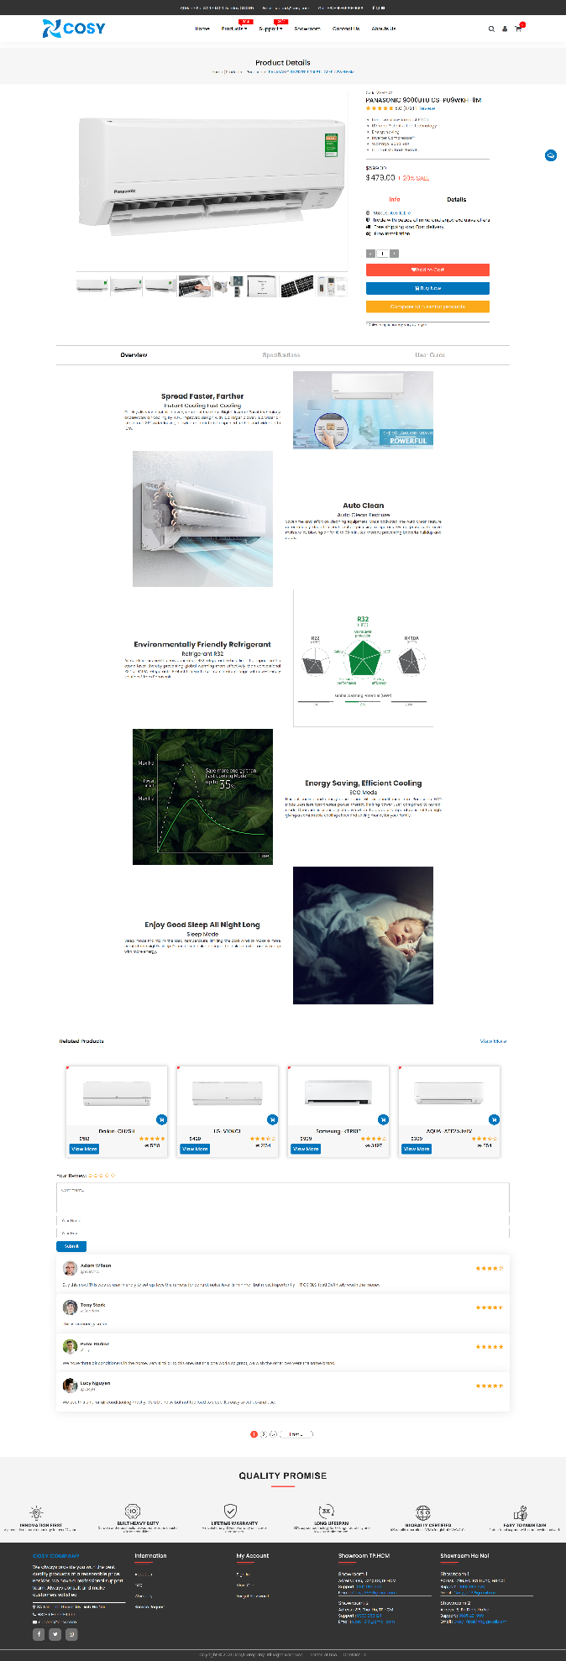

* 1. Support Pages
* Warranty Page: Our terms and warranty condition

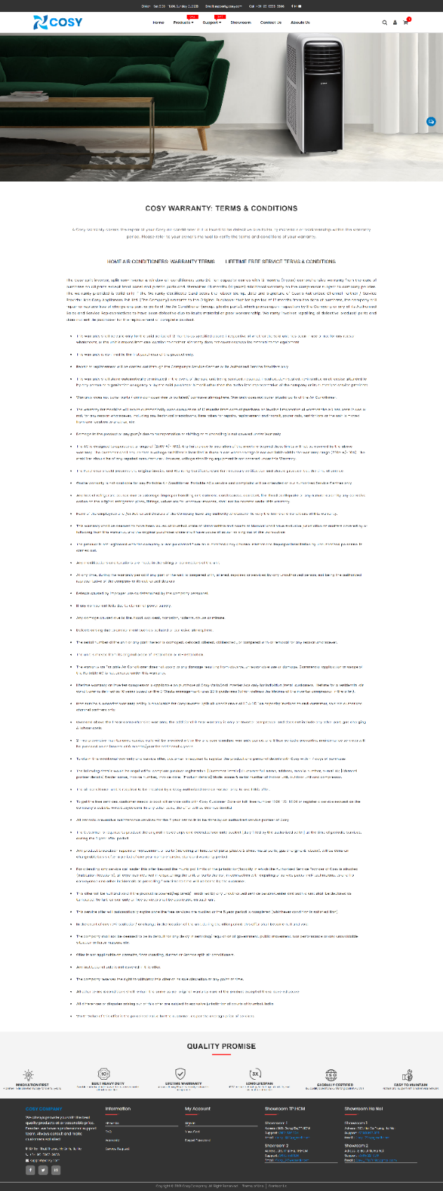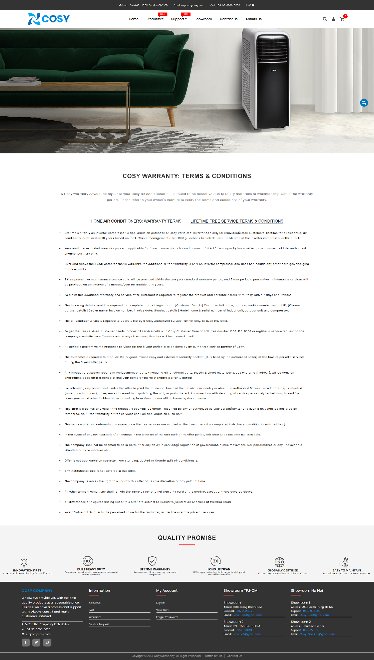

* Service request Page: Form for customers to contact our company.

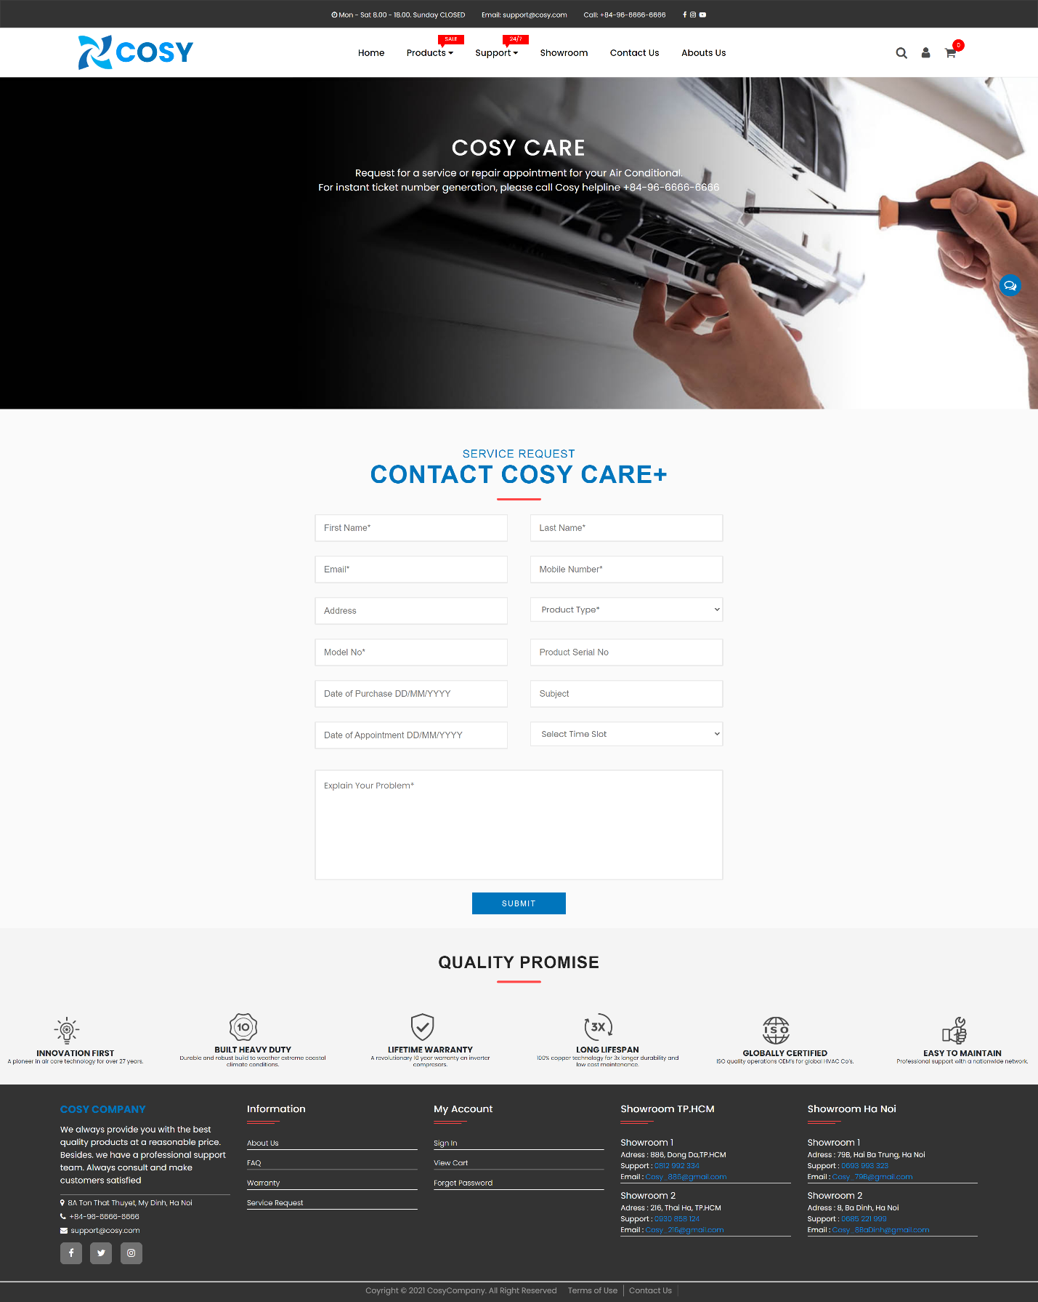

* FAQ Page: A list of Frequently asked questions and the answer.

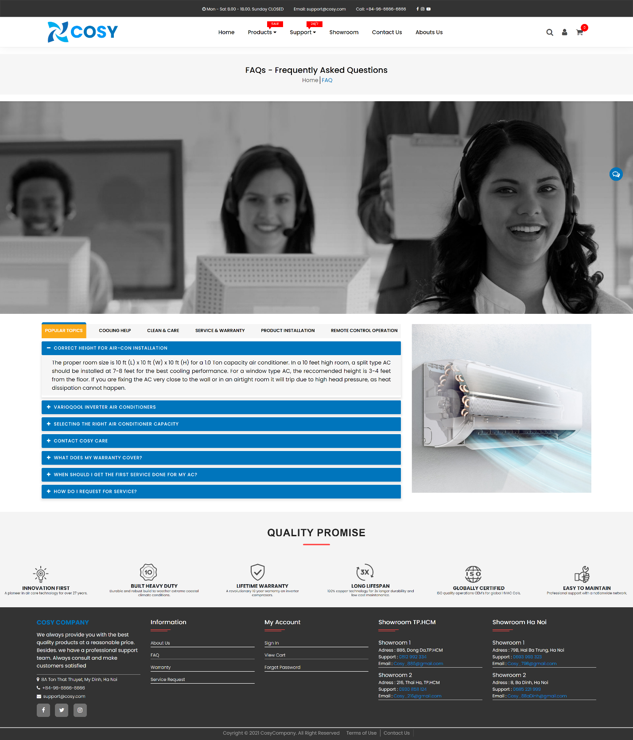

* 1. Showroom page

Our showroom loction, our contact form and contact information.

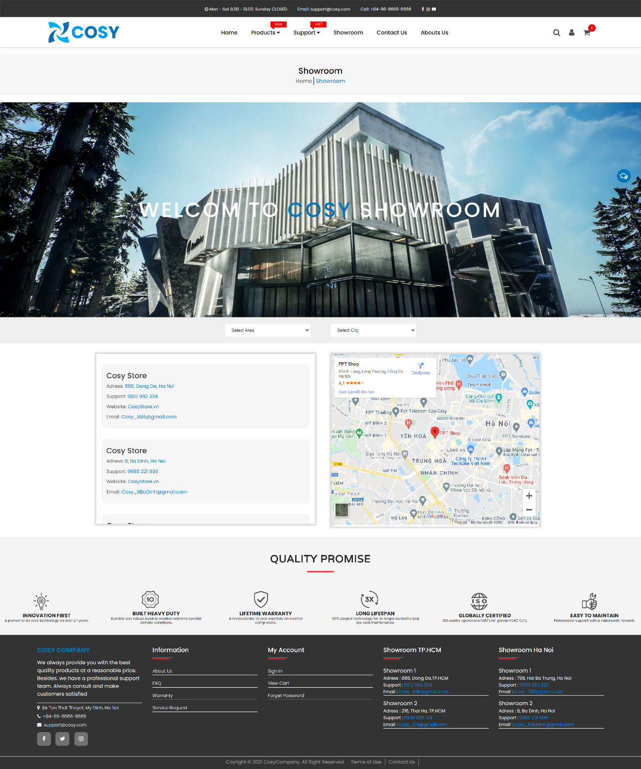

* 1. Contact Us Page

Our showroom loction, our contact form and contact information.

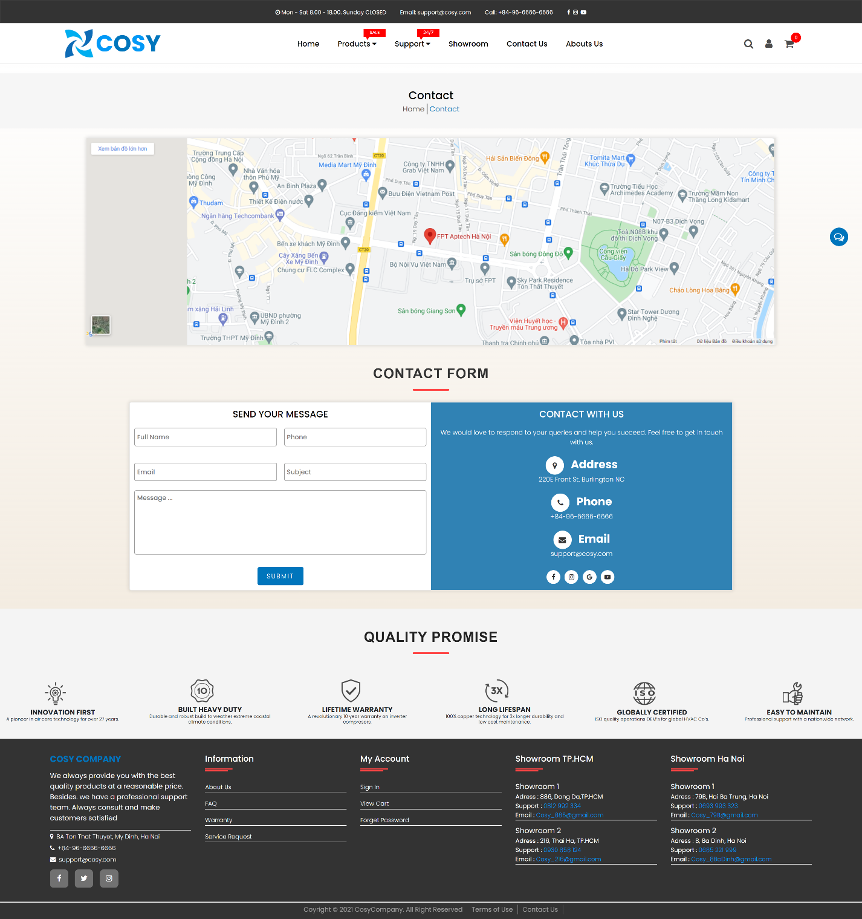

* 1. About Us Page

Introduce our team and our company.

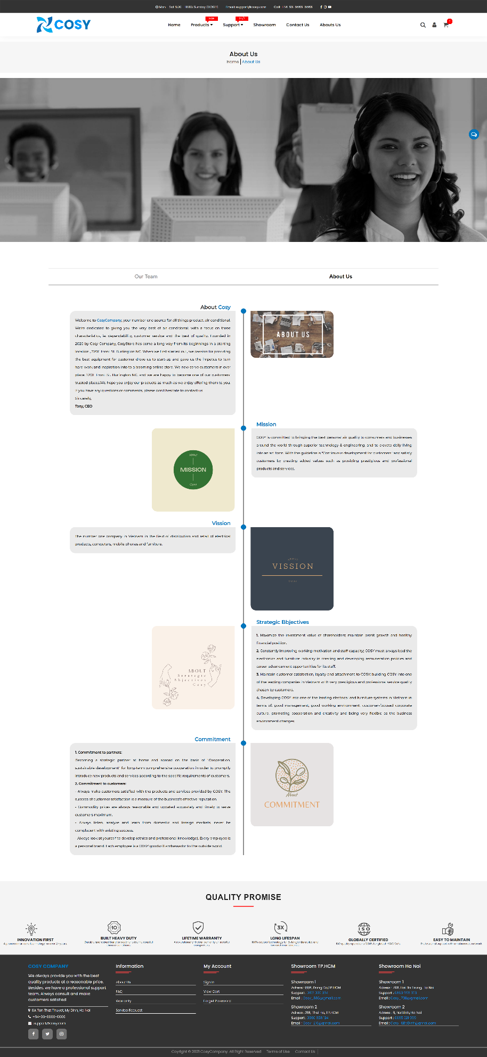

* 1. Checkout Page
* Billing Address: Name, Address, Phone, Email.
* Shipping Options: Shipping Services.
* Billing Options: Credit Card, Paypal, Cash Only.
* Review Your Order: Review products and add note.

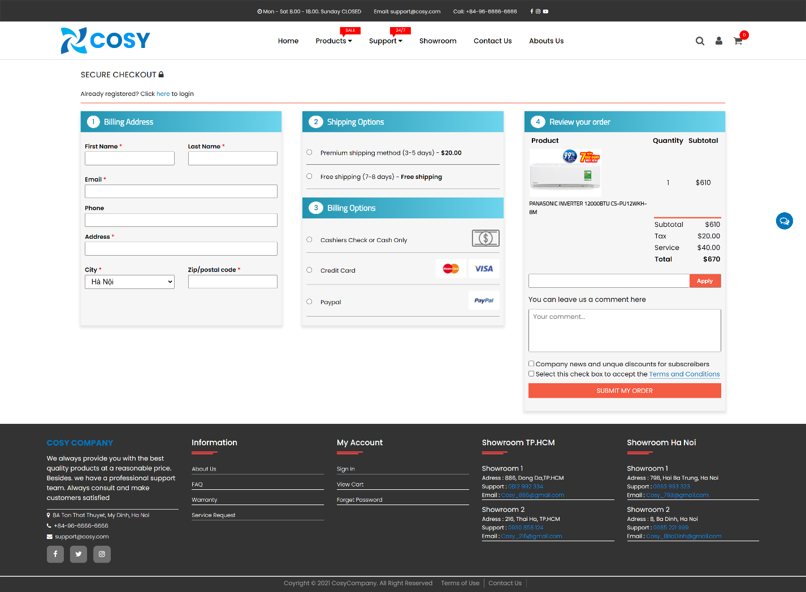

* 1. News & Experiments

Our news and experiments

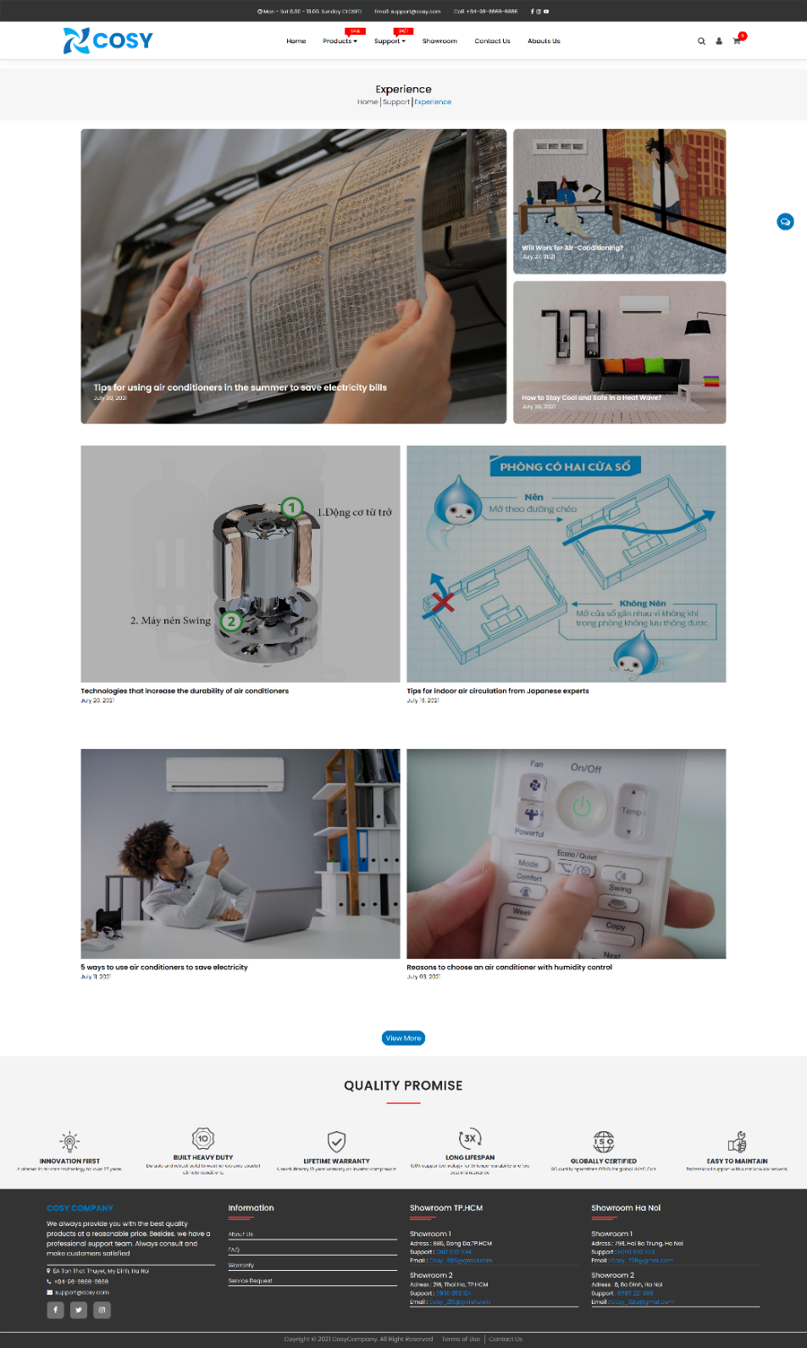

# Site’s map

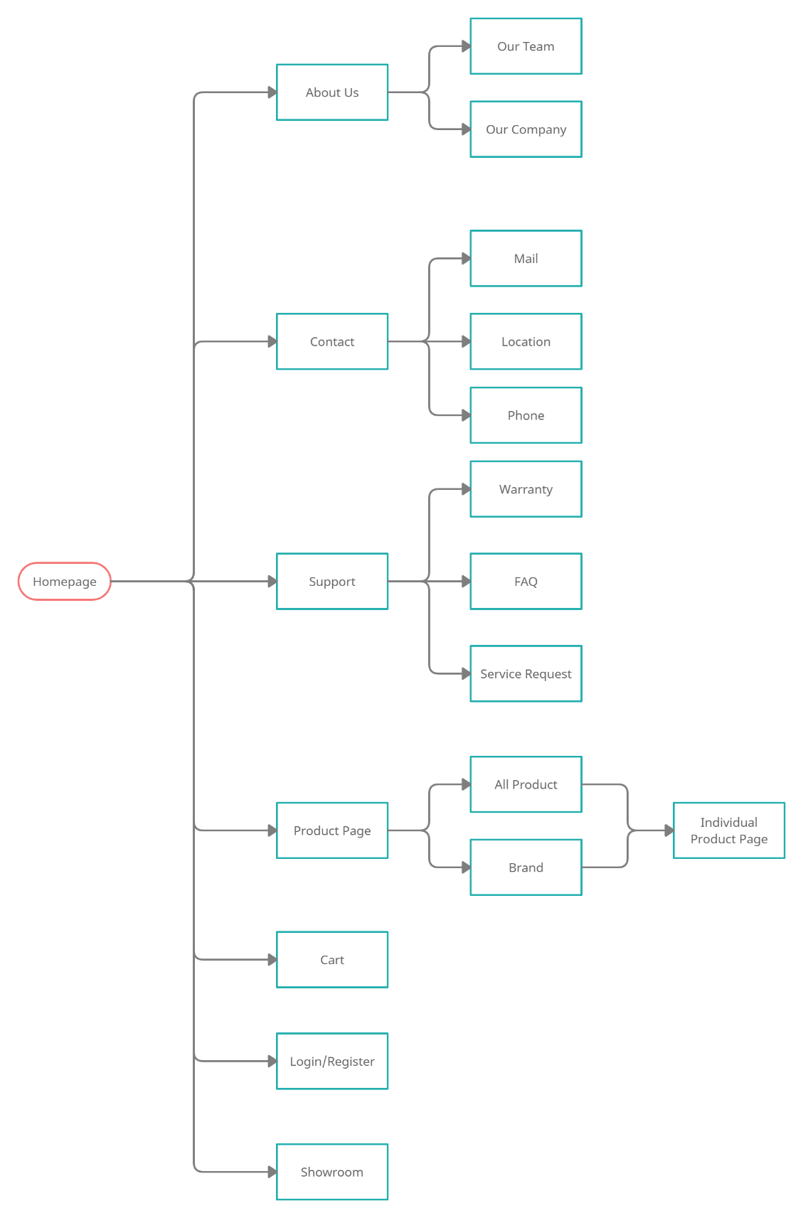

# User’s Guide

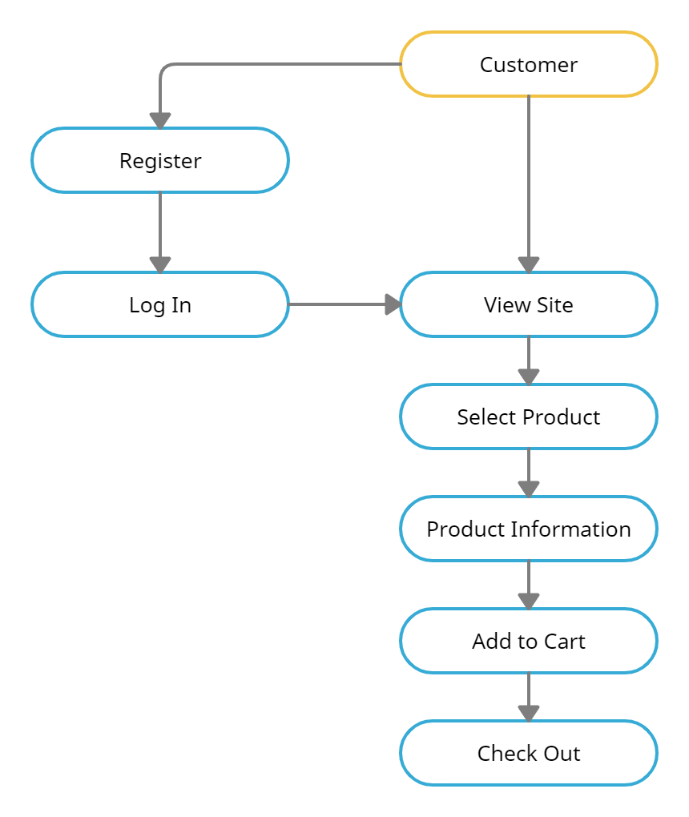

1. Register and login

You can register as a new member or login by click this icon on top of website:

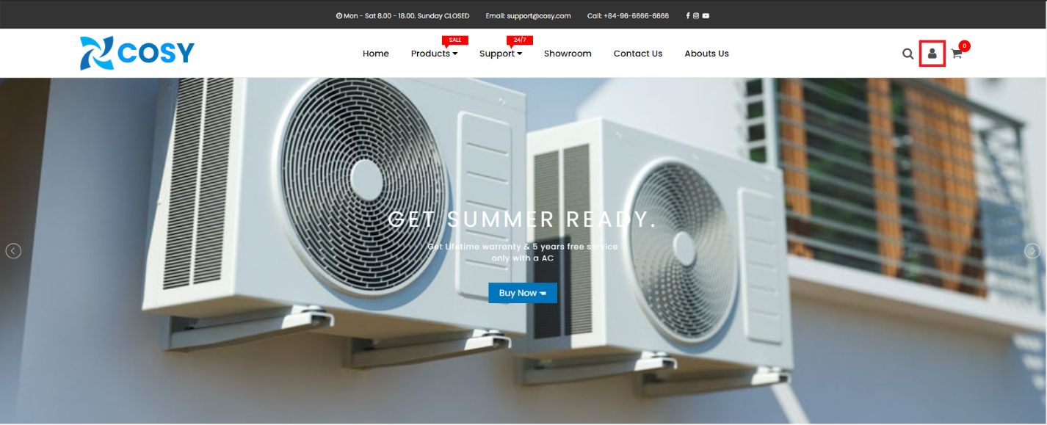

A popup will pop out like this:

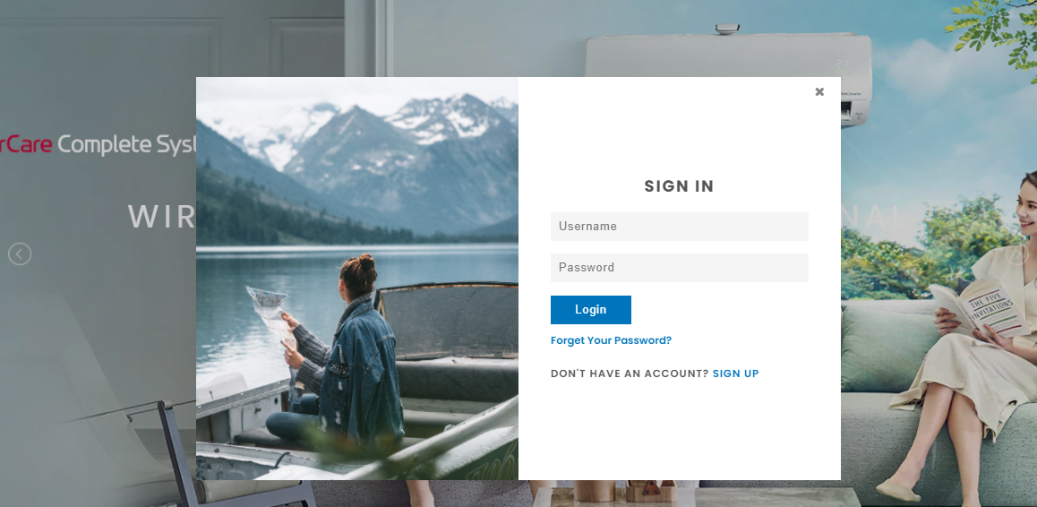



1. Website Link

At the index page we have quick-link sections where you can access to new products or products-on-sale individual page:

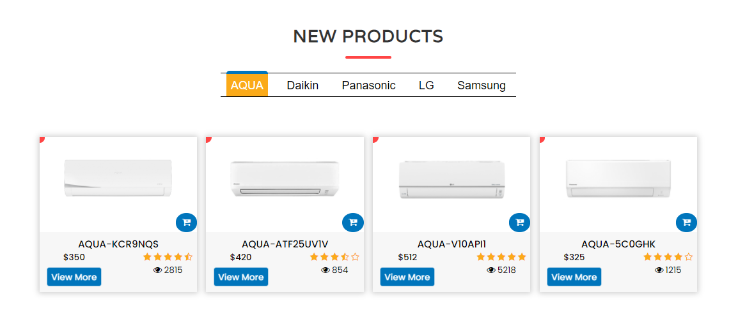

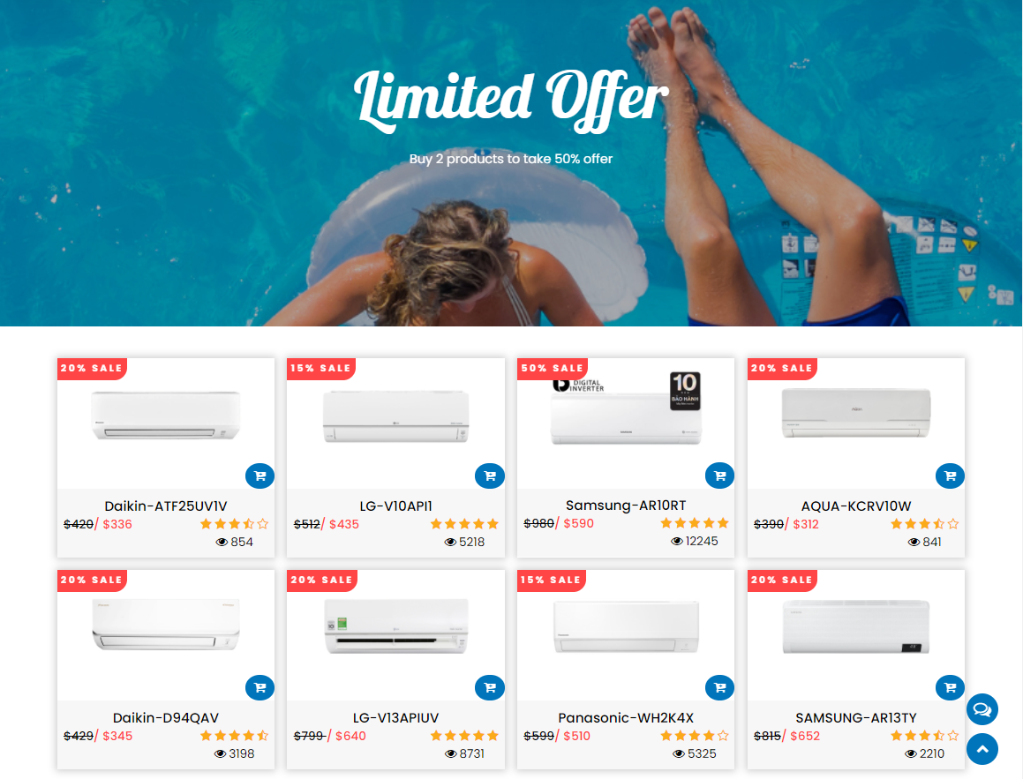

Or you can search for product by this



Besides, you can view the product through the all product page or product by brand page through these quick link:

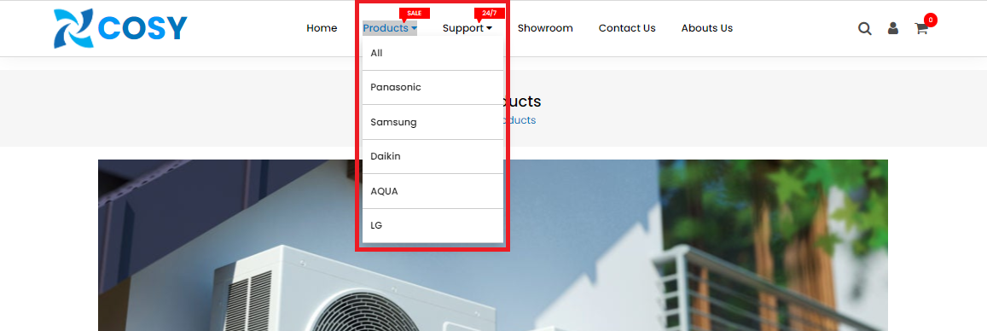

This section will help you answer your questions and seek help from us:

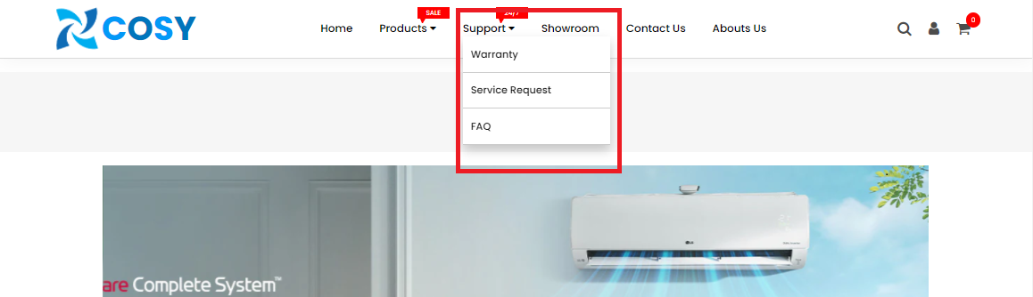

Here to show you our showroom’s location page:

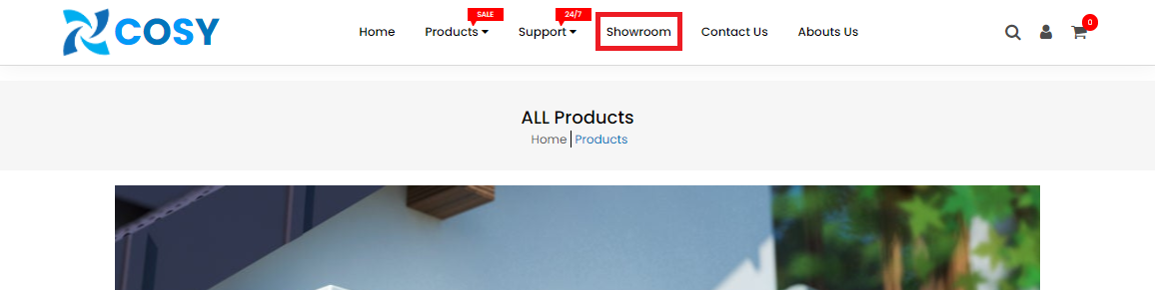

Our contact form and contact information will show if you click here:

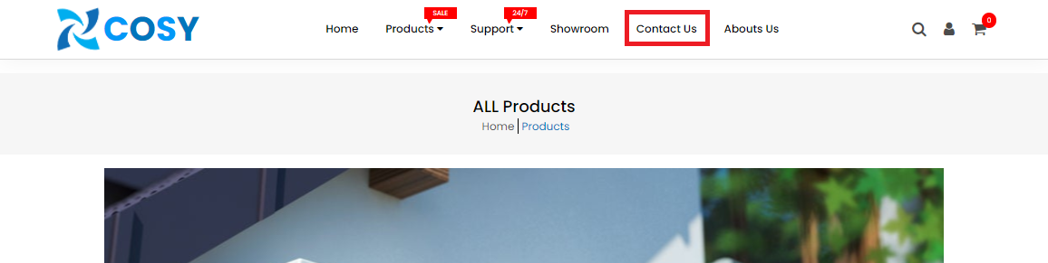

You will find out more information about our company and our team through this:



Review selected products by clicking this button:

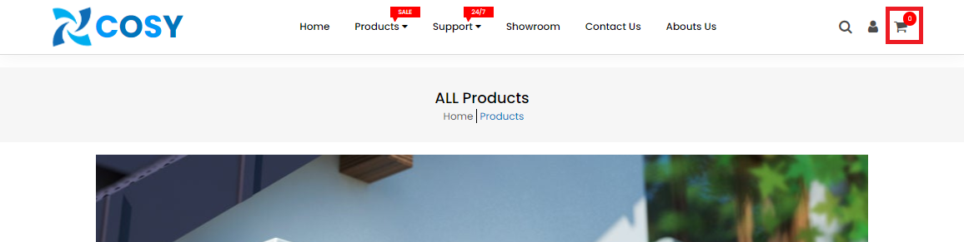

At footer section, we have social link to our fanpages:

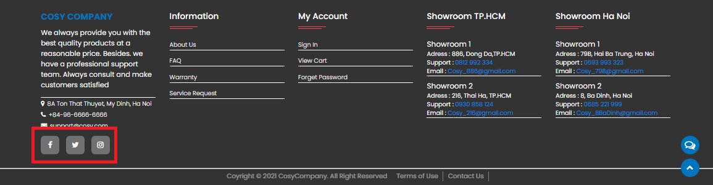

Start conversation with our customer care staff:

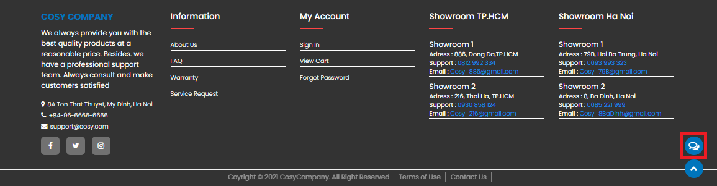

Scroll to top of page

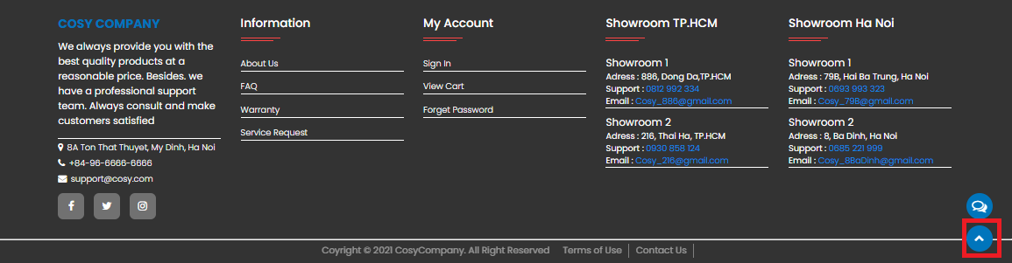

1. Shopping guide

You may add a product to your cart to see additional options or go to checkout when you discover something you like. Moreovers, you can compare it to other items:

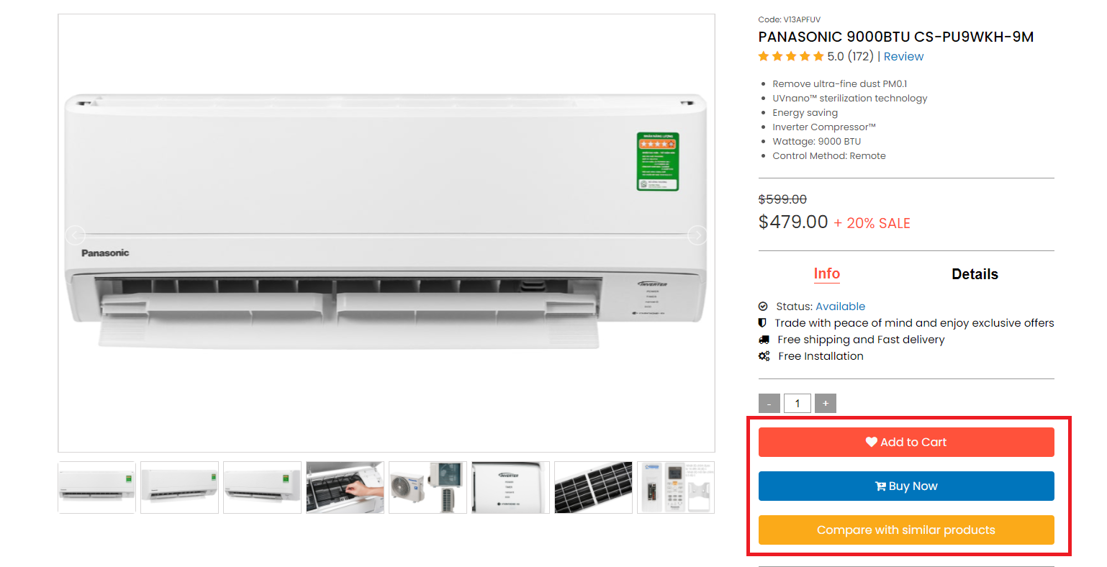

The final step is to completely fill out the form and select your selections in order to place an order:

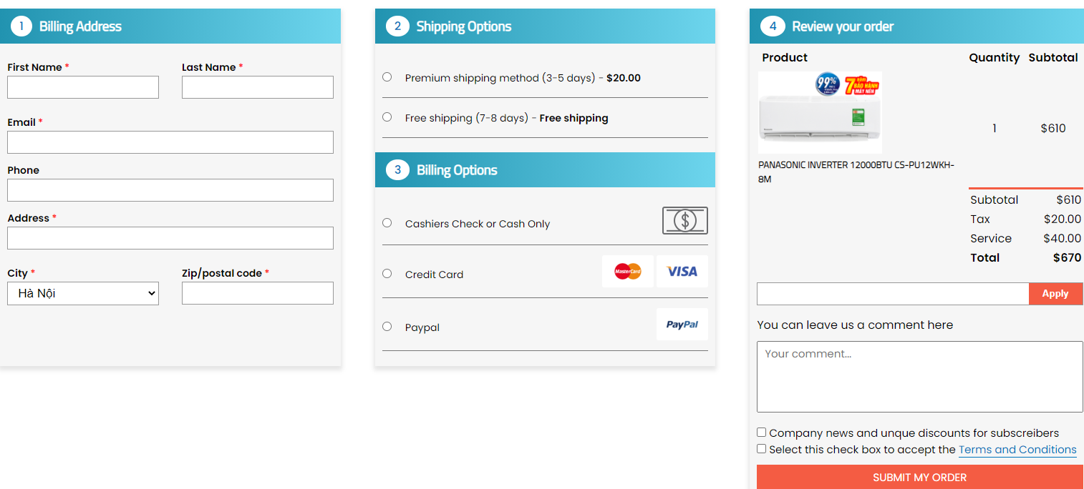

# Developer’s Guide

The website is built using HTML5, CSS3 (with grid and flex for layout), Javascript, Geolocation, and Jquery. If developer want to keep the site up to date, please follow these instructions

1. Download source code

* Go to [https:www.github.com/cosystore/cosy.github.io](https://www.github.com/cosystore/cosy.github.io)
* Click on button: “Code”
* Click “Download as zip”
* On cmd, choose the folder to save project then type command: git clone [https:www.github.com/cosystore/cosy.github.io](https://www.github.com/cosystore/cosy.github.io)

1. Maintain HTML code

We separate source code into 21 pages, each page namely: [Name of page].html. See the illustration below:

* Every part of each page is noted to define each part. Example:

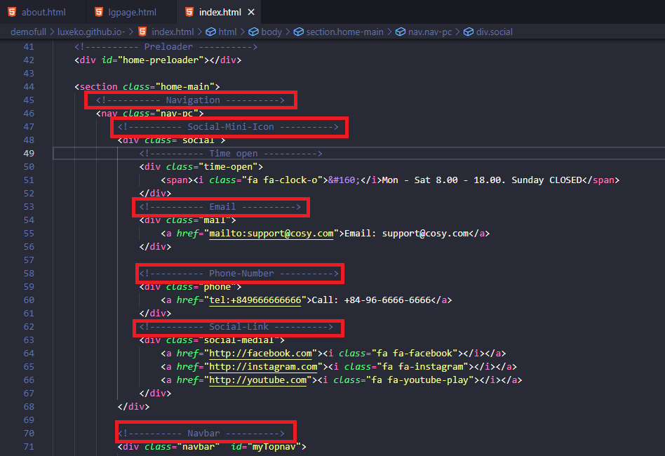

* Find the part name and make the necessary changes to the source code for maintenance.

1. Maintain responsive

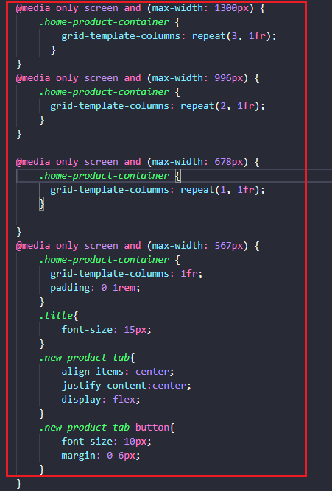

1. Maintain javascript

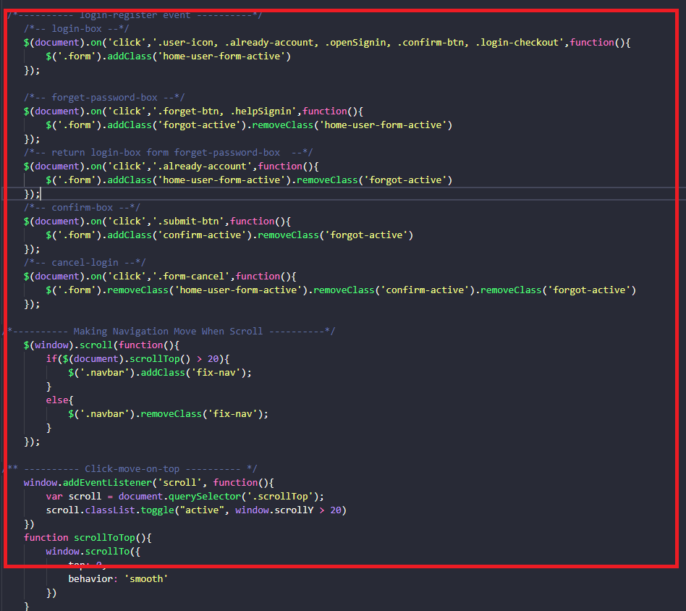

1. Extension

* Install “live server” in Visual studio code for run live website (no need to reload website when every time update source code) follow step by step below:

Click on Extensions button on Visual Studio Code.

* Type “live server” on search bar.
* Click on “Install” and wait to setup complete.
* Restart Visual Studio code.

1. Browser support

* Support chrome browser version 57.0 and above.
* Support firefox browser version 52.0 and above.
* Support IE browser version 11.0 and above.